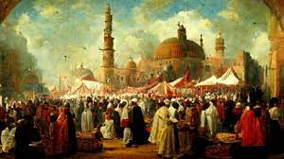
Mawlid, also known as Mawlid al-Nabi, is a significant observance in Islam that commemorates the birth of the Prophet Muhammad.

MAWLID

